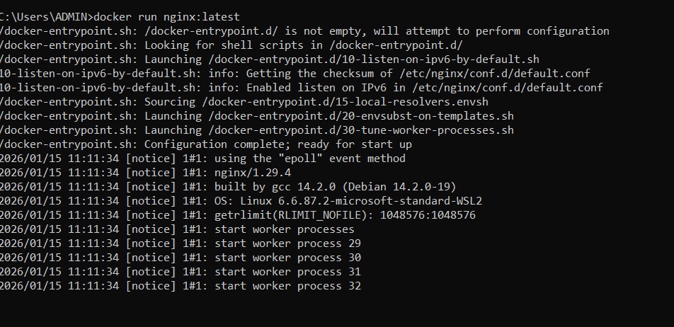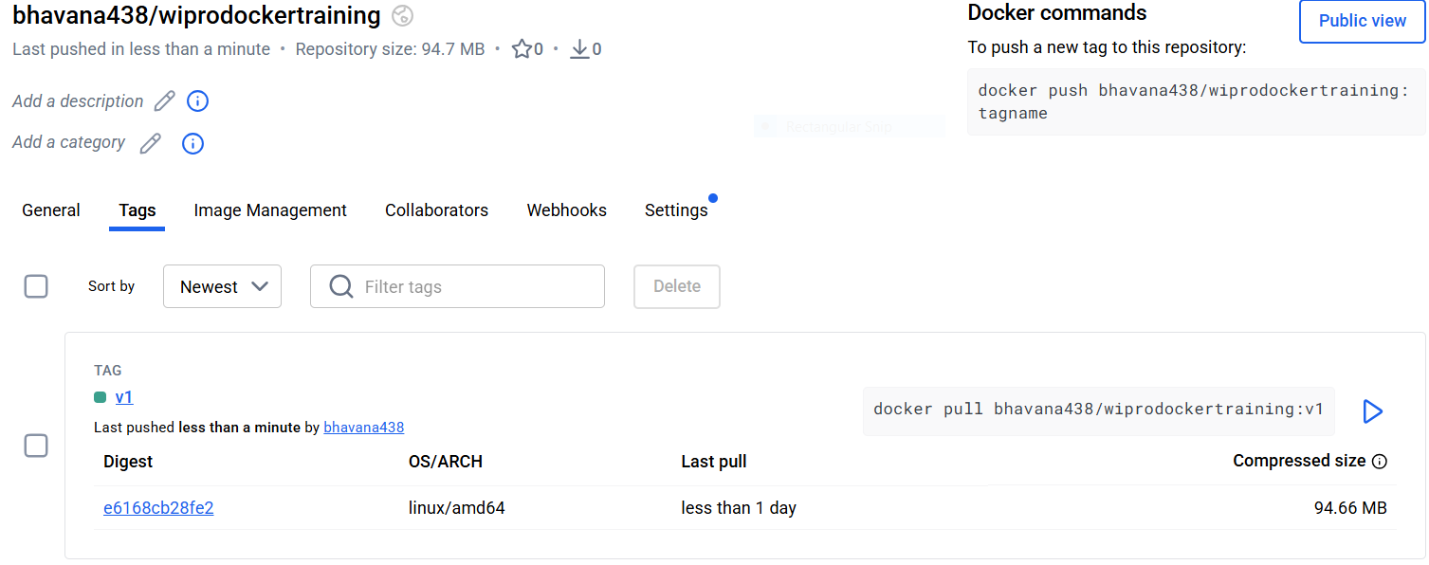

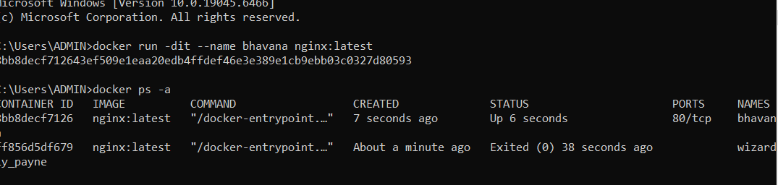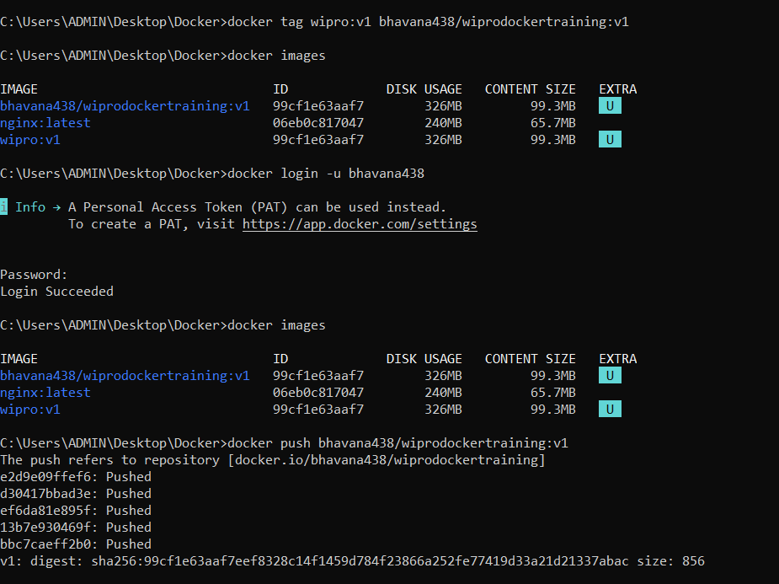
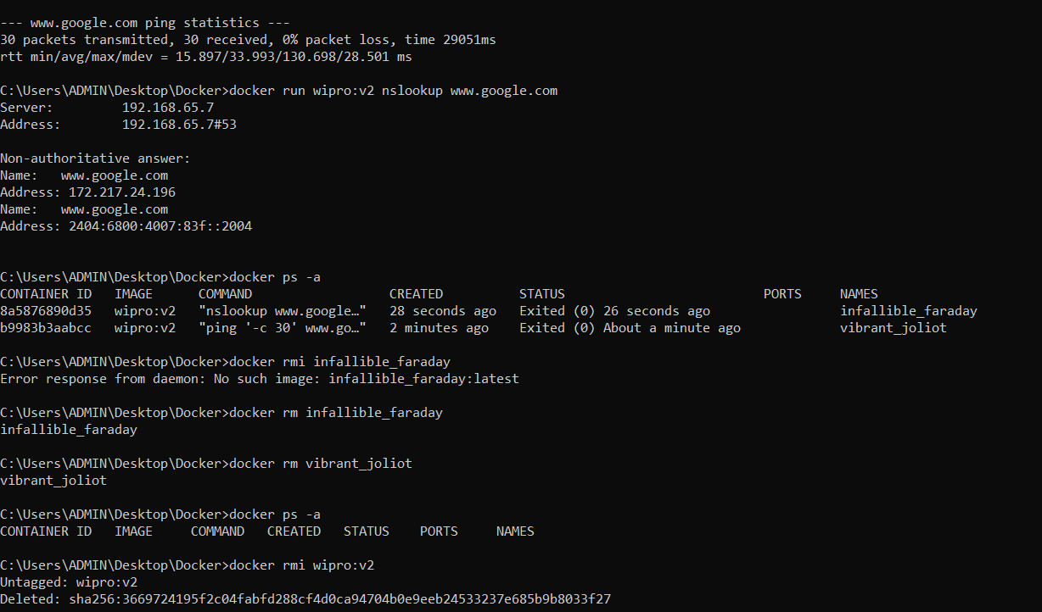
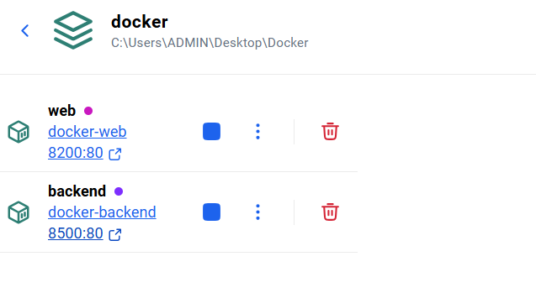

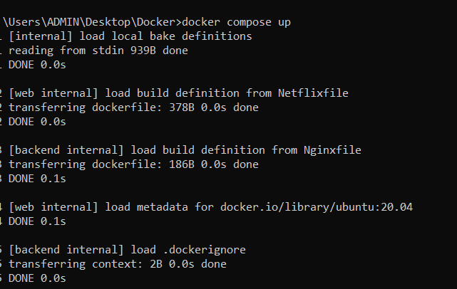
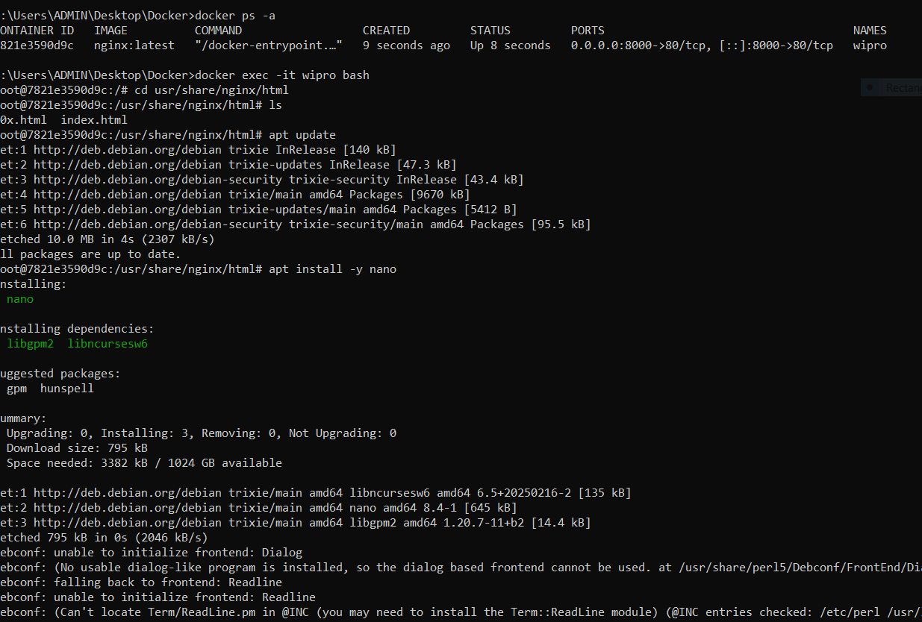
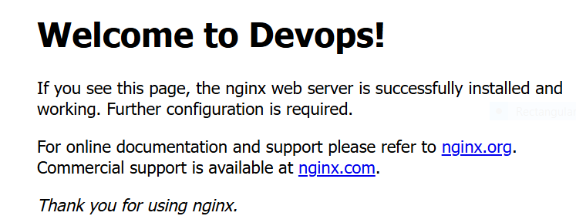
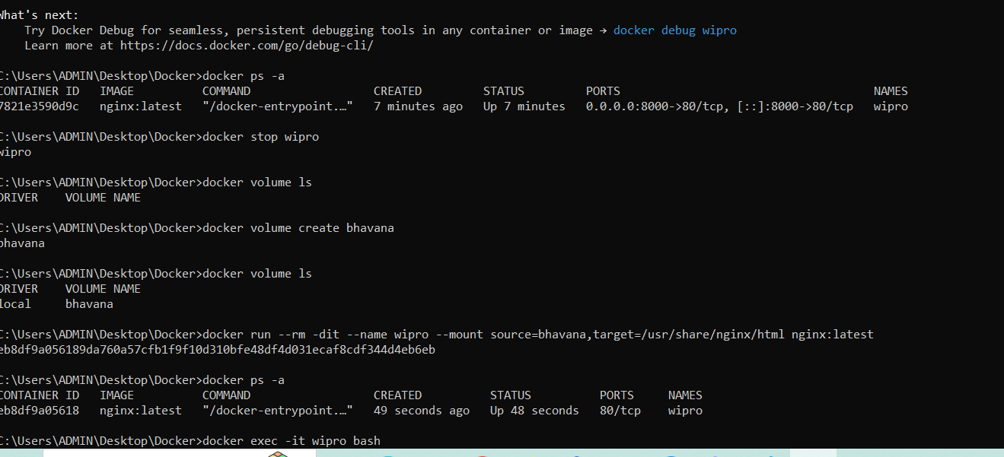
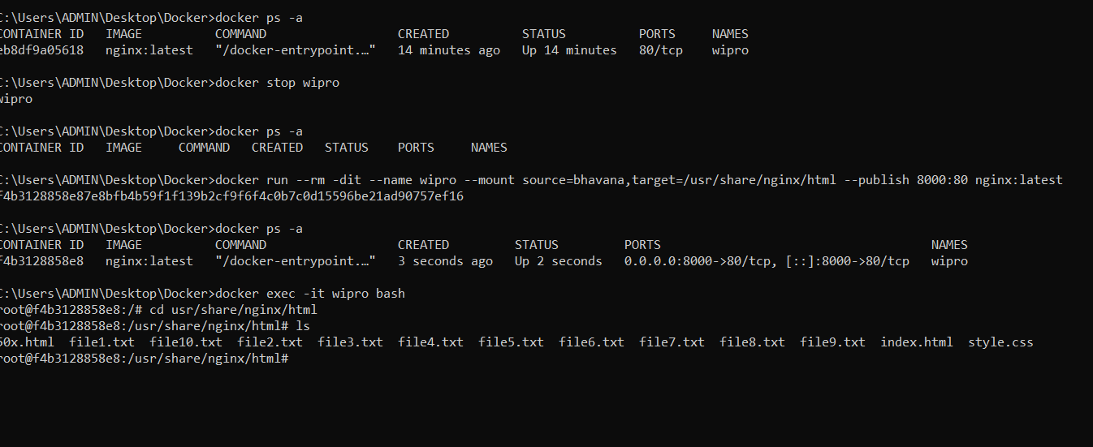
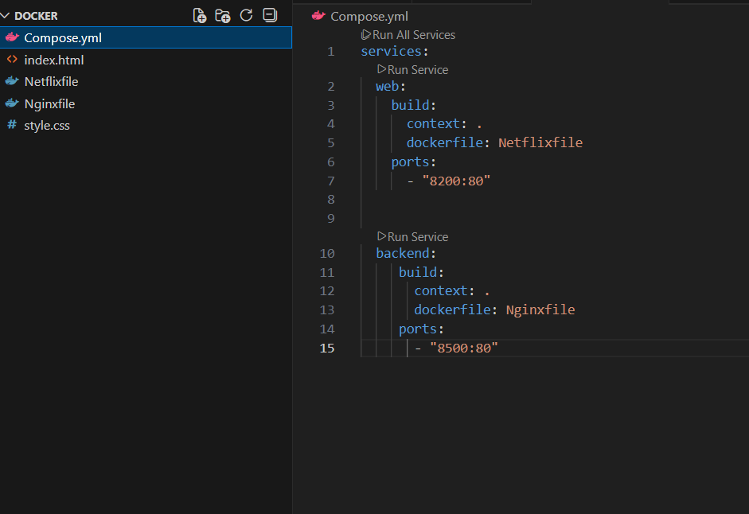
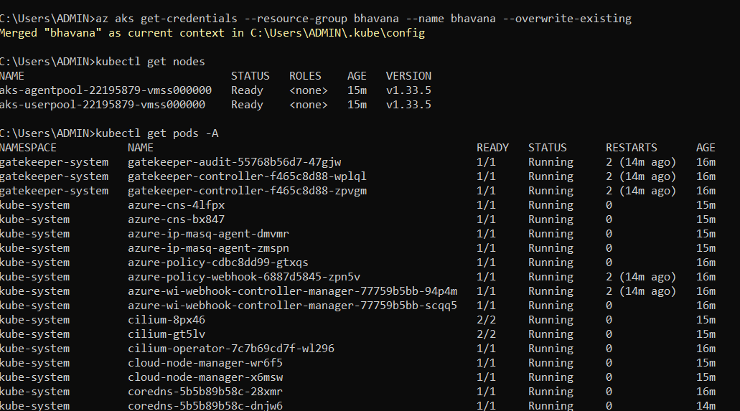
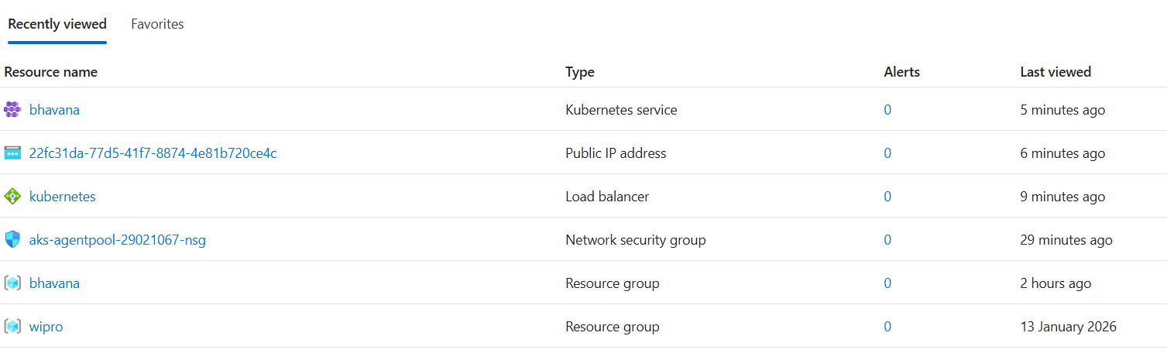

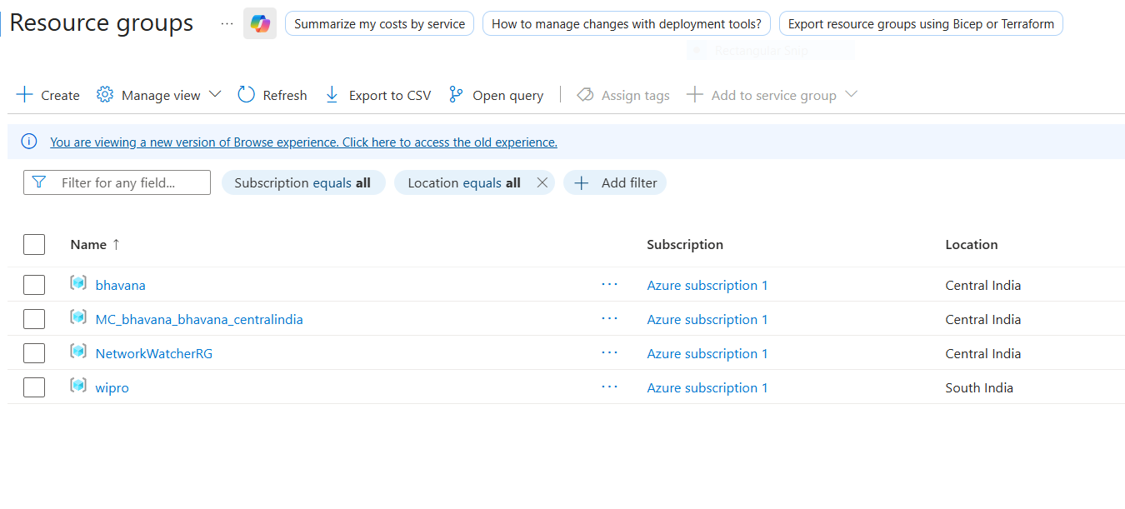

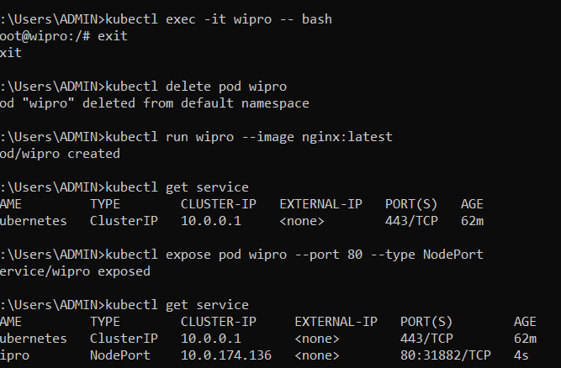
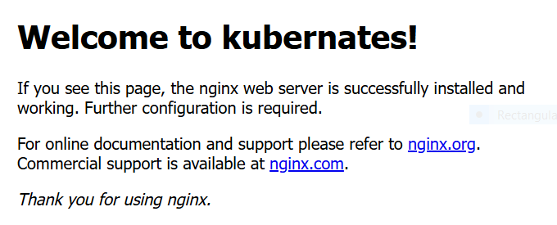

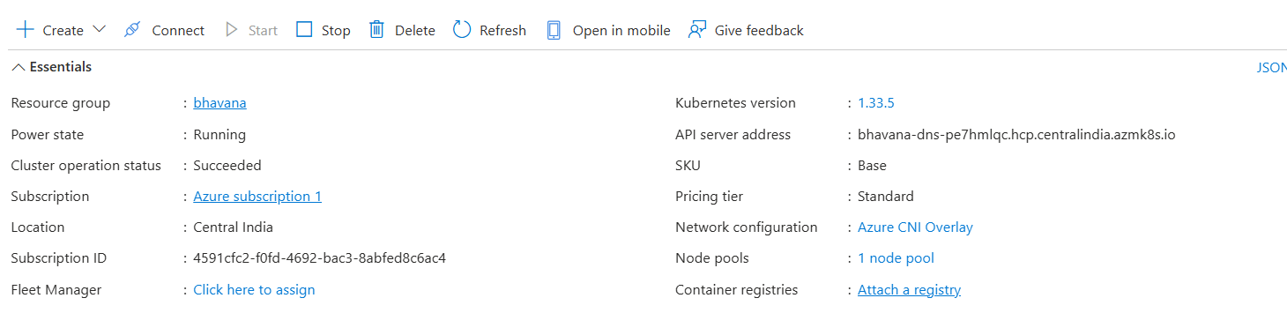

Commands
1.Create container
Docker run nginx:latest
2.Run container in detached mode with name:
Docker run –dit –name bhavana nginx:latest
3.Check all containers
Docker ps –a
4. Login to container
Docker exec –it bhavana bash
5.Remove the container
Docker rm bhavana
6. Run nginx with post mapping
Docker run –rm –dit –name bhavana –publish 8080:80 nginx:latest
7. Go to nginx html path:
Cd /usr/share/nginx/html
8. install nano:
Apt install
Apt install –y nano
Volume ls
Volume create bhavana
docker run --rm -dit --name wipro --mount source=wipro,target=/usr/share/nginx/html nginx:latest
kubectl run wipro --image nginx:latest
kubectl describe pod wipro
kubectl exec -it wipro -- bash
kubectl get service
kubectl expose pod wipro --port 80 --type NodePort
kubectl delete service wipro
kubectl delete pod wipro
kubectl get deployment
kubectl create deployment wipro --image nginx:latest --replicas 10
kubectl scale deployment wipro --replicas 30
kubectl expose deployment wipro --port 80 --type LoadBalancer
kubectl get service
kubectl delete service wipro
kubectl delete deployment wipro

